**Flagstaff High School**

**Strength & Conditioning**

**Mobility exercises**

Do each exercise for 15-20 seconds

**Spine** – hands and knees position, arch back up and down

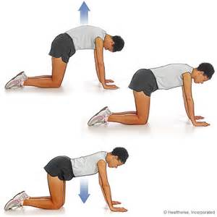

**T – spine** – side lying position with knees and hips bent, extend your arms in front of you, reach back with the upper arm causing your upper body to twist

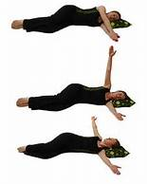

**Y, T, W, L** – standing position with your back to a wall, form I, Y, T and W patterns with your arms touching the wall (or as close to the wall as possible)

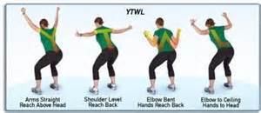

**Arm Circles** – standing or seated position, circle arms forward and backward

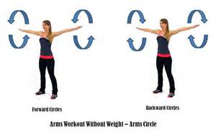

**Hip Circles** – standing or hands and knees position, lift leg and circle hip forward and backward

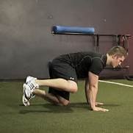

**Neck** – standing or seated position, forward ½ circle, backward ½ circle, side-to-side bend

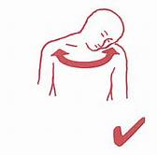

**Ankle** – standing, seated or lying down position, alphabet exercises – spell the alphabet with your foot

