**Sprint and Change-of-direction workout**

Jog 2 minutes and do the team dynamic workout

1st quarter – sprint 20 seconds, walk/jog 40 seconds x 4 sets

Backward run 30 yards x 4 with 10 seconds rest between

Sprinters x 10 each leg

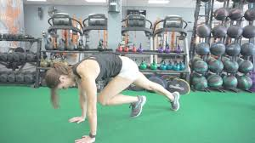

Rest 1 minute

2nd quarter – sprint 15 seconds, rest/walk 15 seconds x 8

Carioca x 30 yards x 4 with 10 seconds rest in between

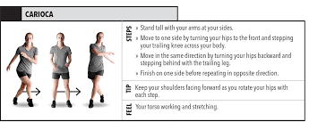

Toe/heel walk 4 x 30 yards (2 sets on toes, 2 sets on heels)

Rest 1 minute

3rd quarter - sprint 20 seconds, walk/jog 40 seconds x 4 sets

Zigzag run 40 yards x 4 with 10 seconds rest in between

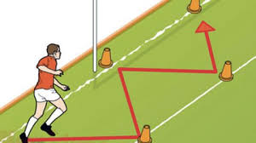

Single leg balance with eyes closed 2 x 30 seconds each leg

Rest 1 minute

4th quarter - sprint 15 seconds, rest/walk 15 seconds x 8

Shuffle 30 yards x 4 (2 leading with right leg, 2 left leg)

Single leg bridge x 15 each leg

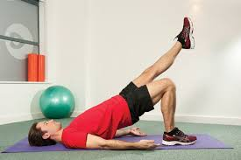

Recovery walk x 1 minute

Stretch

**Aerobic endurance workout**

**This is to build an aerobic base to help you recover between sprints along with some prevention exercises.**

**Run 1 -2 miles at a fairly easy pace**

**Single leg toe/heel raises 2 x 20 each leg**

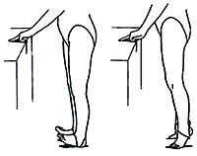

**Figure-4 get up x 8 each leg**

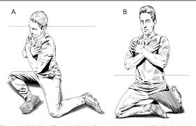

**Groin ball/pillow squeeze x 20**

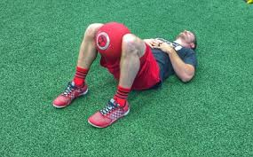

**Short Sprint Ladder**

**Jog 2 minutes, team dynamic warmup**

**sprint 10 yards, rest 5 seconds**

**sprint 20 yards, rest 8 seconds**

**sprint 30 yards, rest 12 seconds 1 set (1 quarter)**

**sprint 40 yards, rest 20 seconds**

**sprint 50 yards, rest 30 seconds**

**rest/walk 2-3 minutes**

**Repeat the whole set 4 times (4 quarters)**

**Long Sprint Ladder**

**Jog 2 minutes, team dynamic warmup**

**1st quarter**

**Sprint 50 yards, rest 20 seconds**

**Sprint 100 yards, rest 40 seconds**

**Sprint 150 yards, rest 60 seconds**

**2nd quarter**

**Sprint 200 yards, rest 90 seconds**

**Sprint 300 yards, rest 2 minutes**

**Sprint 400 yards, rest 3-4 minutes**

**3rd quarter**

**Sprint 400 yards, rest 3-4 minutes**

**Sprint 300 yards, rest 2 minutes**

**Sprint 200 yards, rest 90 seconds**

**4th quarter**

**Sprint 150 yards, rest 60 seconds**

**Sprint 100 yards, rest 40 seconds**

**Sprint 50 yards**

**Walk 1 minute**

**Stretch**