**FLAGSTAFF EAGLES BASEBALL STRENGTH TRAINING PROGRAM**

**SUMMER – FALL 2021**

Introduction and Important Strength Training Concepts

* *CONSISTENCY and LONGTERM perspective*

Developing and increasing your strength is a process that takes *consistency* and *time*. Without lifting on a regular schedule (*consistency*), you lose gains between your training sessions and just won’t make much progress. The *longterm* or “time”part of the training “puzzle” means that you won’t see immediate changes to your actual strength or physical size overnight.

You should expect that after one-month of lifting, you will begin to feel stronger, and might notice a *little* more definition in your musculature. After two months of consistent training, you will definitely feel stronger and will notice an increase in muscle tone and size. You will have likely gain a few pounds. After 6 consistent months of strength training, you will be much stronger than when you started, will have gained 5 or more pounds of muscle, will be less prone to injury, and will notice an improvement in your physical abilities on the field! At this stage, this is where you really get excited because all of the hard work is beginning to “pay off”.

* *QUALITY over QUANTITY!*

The amount of time you put into perfecting your motions (*quality)* during each and every lift you do lead to much larger and quicker strength gains that simply adding more weight (*quantity*) and struggling to find a way to get the repetition or set completed. Once your body has memorized the correct movements, then and only then, can you safely begin to build strength and slowly increase resistance. “*Devaluing movement in favor of strength results in compensations, breakdowns, and eventually injuries*” [From “Movement Over Maxes by Zach Dechant]. Almost every lifting movement in your three-day per week training program is accompanied by a detailed video (by former MLB pitcher Ken Roberts among others) that shows the correct movements. This is not a trivial aspect of the training program. Make sure you are moving correctly during your exercises!

* *GOOD PAIN* *versus BAD PAIN*

There are two basic types of pain in resistance training and one is very good and the other is very bad. The *good pain* is that uncomfortable sensation that you likely have already experienced when pushing yourself (your muscles and/or cardio vascular system) hard during a workout. It is the “burning” sensation in muscles associated with the fatigue and the build-up of lactic acid in your muscles as they near exhaustion. *Bad pain* is often more of a stabbing or sharp pain that can accompany muscle strains and is more indicative of acute injury. Maintain good form (*quality movement*) and lift an appropriate amount of weight and you will likely avoid the bad pain and injuries during resistance training.

* *NEGATIVE REPETITION (*or *“neg rep”* for short) When a muscle contracts (shortens) that is called concentric movement: think of a basic bicep dumbbell curl where you lift the weight from the low position near your hip to the curled position by your shoulder). As you lower the weight in a bicep curl, the muscle is lengthening while it is doing work – this is the *negative rep*. Don’t lose out on the added strength gains that come with the *negative rep* by just letting the weights fall quickly back to their original position. *SLOWLY* unload your muscles by returning weight to its original position over 2 to 3 second count. This goes for ALL lifts.
* *YOU ARE THE COMPETITION*!

DO NOT compare your self to others as you begin and progress in your strength training program. The only person that you are competing against is *yourself*….wanting to not go lift because you’re tired, wanting to skip that last set or last couple of reps in a set – these are the battles of the mind that you are competing against and they are internal. No matter what level you are playing and/or training at (high school, college, etc) there will always be someone stronger and faster than you. Your goal is to maximize your “positive delta” – that is the percent increase in the positive direction in some aspect of your training or play. Commit to pushing yourself because you want to do your best, and be satisfied when you know you’ve given it your all. If you do that, it doesn’t matter what anyone else achieves.

Pre-Lifting Warm-Ups

* Jump-rope: 2 sets of 30 seconds each, 30 seconds rest in between.
* Inchworm: 5 repetions
* Jump-rope: 1 set x 1 minute
* Reverse lunge to high knee: 5 reps each leg
* Light skips: 10 yards (30 feet)
* Lateral skips: 10 yards (30 feet)
* Jump-rope: 2 set x 1 minute

** Demonstration videos for the warm-up are at the end of this document!

Overview of Training Exercises and Tempo

The strength training program below is broken into a 3-day per-week total-body approach: you will do a full-body workout three days per week. Most of the lifts are different for each of the days because changing up the lifts gives your muscle groups a slightly different “look” which quickens strength gains and provides a more complete range of movements that your body must master.

Lifts are broken into “blocks of two”: you will complete a single set from the “A” block for the given group (a group is like “1”, or “2”, or “3”) and then proceed directly to the “B” block lift. Then you will rest 1 to 1.5 minutes and then complete the next set of the “A” block in the same group. So you will finish all of the “1” group sets before moving to the “2” group sets, then finish all sets of “A” and “B” in the 2 group before moving to the “3” group. Often, the two lifts in a given group are actually hitting opposing muscles or one of the blocks is more of a stretching type lift to lengthen muscles after the previous set of the previous block.

|  |  |  |  |  |  |  |  |  |  |  |
| --- | --- | --- | --- | --- | --- | --- | --- | --- | --- | --- |
|  | **Day 1** | | **Week 1** | | **Week 2** | | **Week 3** | | **Week 4** | |
|  | Weight | Reps | Weight | Reps | Weight | Reps | Weight | Reps |
| 1A | Pushups | | 3x10 | | 3x12 | | 3x15 | | 4x15 | |
| BW | | BW | | BW | | BW | |
| 1B | Band Pullapart | | 3x10 | | 3x10 | | 3x10 | | 3x10 | |
|  |
|  | | | | | | | | | | |  |
| 2A | Cable Row - Single Arm Each Side | |  | 10 |  | 10 |  | 8 |  | 8 |  |
|  | 10 |  | 10 |  | 8 |  | 8 |  |
|  | 10 |  | 10 |  | 8 |  | 8 |  |
|  | 10 |  | 10 |  | 8 |  | 8 |  |
| 2B | No Money | | 3x10 | | 3x10 | | 3x10 | | 3x10 | |  |
|  |
|  | | |  | | | | | | | |  |
| 3A | Inverted Row | | BW | 8 | BW | 8 | BW | 10 | BW | 10 |  |
| BW | 8 | BW | 8 | BW | 10 | BW | 10 |  |
| BW | 8 | BW | 8 | BW | 10 | BW | 10 |  |
|  | |  | |  | |  | |  |
|  | | | | | | | | | | |  |
| 4A | DB Bicep Curls  Cable Tri- Pressdown  Forearm Curls | |  | 2x10 |  | 2x10 |  | 2x10 |  | 2x10 |  |
|  | 2x10 |  | 2x10 |  | 2x10 |  | 2x10 |  |
|  | 2x10 |  | 2x10 |  | 2x10 |  | 2x10 |  |
|  |  |  |  |  |  |  |  |  |  |  |  |
| 5A | Goblet Squat | |  | 10 |  | 10 |  | 8 |  | 8 |  |
|  | 10 |  | 10 |  | 8 |  | 8 |  |
|  | 10 |  | 10 |  | 8 |  | 8 |  |
|  | 10 |  | 10 |  | 8 |  | 8 |  |
| 5B | Depth Box Drop (Hold for 3 sec) | | 3sets x 5 reps ea. | | 3sets x 5 reps ea. | | 3sets x 5 reps ea. | | 3sets x 5 reps ea. | |  |
|  |
|  | | | | | | | | | | |  |
| 6A | Single Leg RDL | |  | 10 |  | 10 |  | 8 |  | 8 |  |
|  | 10 |  | 10 |  | 8 |  | 8 |  |
|  | 10 |  | 10 |  | 8 |  | 8 |  |
|  | 10 |  | 10 |  | 8 |  | 8 |  |
| 6B | Hip Openers | | 3x10 | | 3x10 | | 3x10 | | 3x10 | |  |
|  |

**CORE:** Planks 2 sets x30 second hold. Sideplanks 2 sets x15 second hold.

VIDEOS AND/OR INSTRUCTIONS FOR DAY 1 LIFTS

**1B**: BAND PULL-APART

[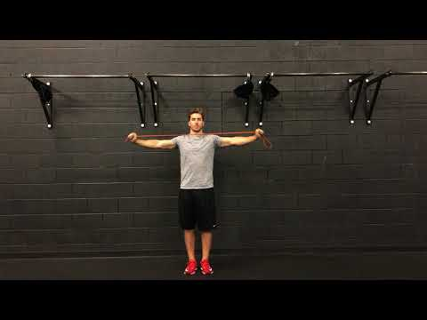](https://www.youtube.com/embed/x3LLokCVkMo?feature=oembed)

**2A**: SINGLE ARM CABLE ROW

[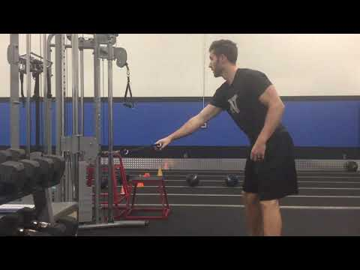](https://www.youtube.com/embed/HVsX4b-AWcs?feature=oembed)

**2B**: NO MONEY

[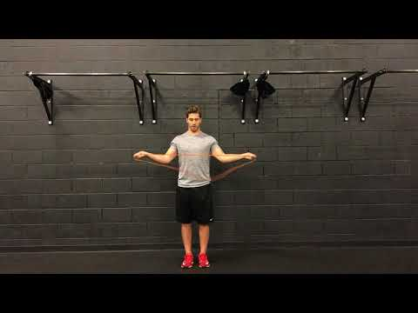](https://www.youtube.com/embed/Q8YAZh6UorE?feature=oembed)

**3A**: INVERTED ROW USING BODY WEIGHT (BW)

[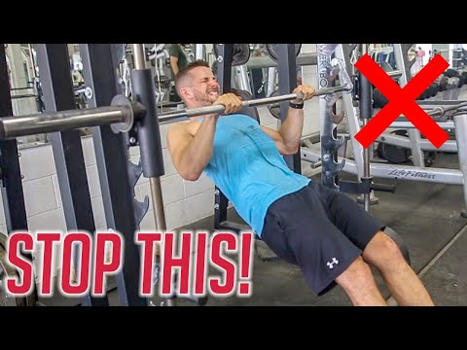](https://www.youtube.com/embed/GdyhjXlxE-U?feature=oembed)

**4A**: DB BICEP CURLS

[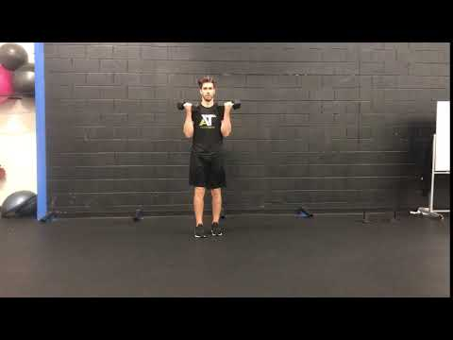](https://www.youtube.com/embed/O3r6je0rO6Y?feature=oembed)

**4A**: TRICEP (ROPE) PUSHDOWNS

Get chest out over hands and rope by an offset stance in feet and keeping chest forward to minimize stress on back.

**4A**: DB FOREARM CURLS

Alternate sets with palm down and rotating knuckles towards body.

Then palms up and rotating palms towards body

Then thumb on top and rotate weight (and thumb) back towards body.

**5A**: GOBLET SQUATS

[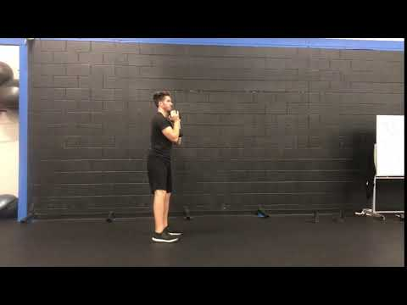](https://www.youtube.com/embed/ovLJNSFPx_Q?feature=oembed)

**5B**: DEPTH BOX DROP

[](https://www.youtube.com/embed/yG8pexv9J6g?feature=oembed)

**6A**: SINGLE LEG RDL (A small weight can be added after MASTERY of the motion!)

[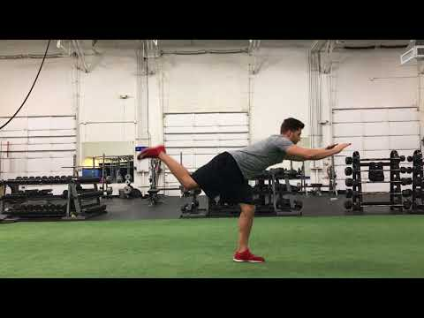](https://www.youtube.com/embed/HNQh7ii0lqo?feature=oembed)

**6B**: HIP OPENERS

[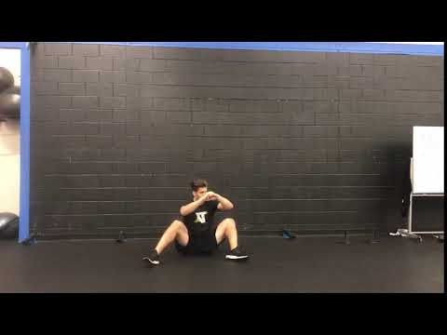](https://www.youtube.com/embed/egZMrWMKOMs?feature=oembed)

**CORE**: PLANK MARCH

[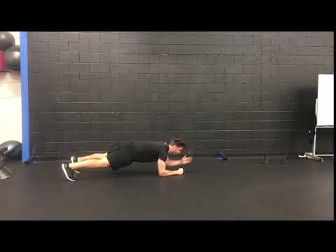](https://www.youtube.com/embed/Wpm8MpUD5x0?feature=oembed)

**CORE**: SIDEPLANKS

[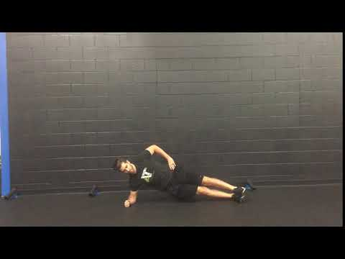](https://www.youtube.com/embed/xLKBPshPWUM?feature=oembed)

|  |  |  |  |  |  |  |  |  |  |  |
| --- | --- | --- | --- | --- | --- | --- | --- | --- | --- | --- |
|  | **Day 2** | | **Week 1** | | **Week 2** | | **Week 3** | | **Week 4** | |
|  | Weight | Reps | Weight | Reps | Weight | Reps | Weight | Reps |
| 1A | DB Benchpress | |  | 10 |  | 10 |  | 8 |  | 8 |
|  | 10 |  | 10 |  | 8 |  | 8 |
|  | 10 |  | 10 |  | 8 |  | 8 |
|  | 10 |  | 10 |  | 8 |  | 8 |
| 1B | Bench T's | | 3x10 | | 3x10 | | 3x10 | | 3x10 | |
|  |
|  | | |  | | | | | | | |  |
| 2A | DB Row | |  | 10 |  | 10 |  | 8 |  | 8 |  |
|  | 10 |  | 10 |  | 8 |  | 8 |  |
|  | 10 |  | 10 |  | 8 |  | 8 |  |
|  | 10 |  | 10 |  | 8 |  | 8 |  |
|  | |  | |  | |  | |  |
|  | | | | | | | | | | |  |
| 3A | Lateral Raises | |  | 12 |  | 12 |  | 15 |  | 15 |  |
|  | 12 |  | 12 |  | 15 |  | 15 |  |
|  | 12 |  | 12 |  | 15 |  | 15 |  |
|  |  |  |  |  |  |  |  |  |  |  |  |
| 4A | Small Weight Shoulder Series (light: 3-5 lbs) | |  | Front |  | Front |  | Front |  | Front |  |
|  | 45 |  | 45 |  | 45 |  | 45 |  |
|  | Side |  | Side |  | Side |  | Side |  |
| 2x10 each | |  | 10 |  | 8 |  | 8 |  |
|  |  |  |  |  |  |  |  |  |  |  |  |
| 5A | DB Step-Up | |  | 8 |  | 8 |  | 6 |  | 6 |  |
|  | 8 |  | 8 |  | 6 |  | 6 |  |
|  | 8 |  | 8 |  | 6 |  | 6 |  |
|  | 8 |  | 8 |  | 6 |  | 6 |  |
|  | | | | | | | | | | |  |
| 6A | DB Reverse Lunge | |  | 8 |  | 8 |  | 6 |  | 6 |  |
|  | 8 |  | 8 |  | 6 |  | 6 |  |
|  | 8 |  | 8 |  | 6 |  | 6 |  |
|  | 8 |  | 8 |  | 6 |  | 6 |  |
| 6B | Medicine Ball Rotation | | 2 set x 5 reps each side | | 2 set x 5 reps each side | | 2 set x 5 reps each side | | 2 set x 5 reps each side | |  |
|  |
|  |

**CORE**:

Cable Anti-Rotation (don’t rotate): 2 sets x 5 reps x 5 sec hold, swap sides between sets

Cable rotation: 2 sets x 10 reps, swap sides (directions) between sets

VIDEOS AND/OR INSTRUCTIONS FOR DAY 2 LIFTS

**1A**: DB BENCHPRESS

[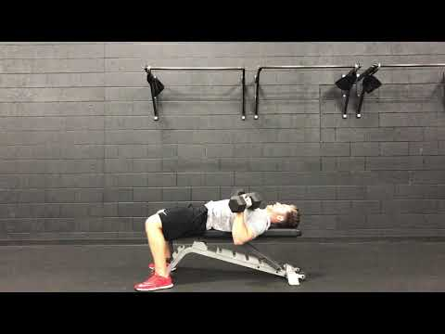](https://www.youtube.com/embed/tsDvkwvtQqQ?feature=oembed)

**1B**: BENCH T’s

[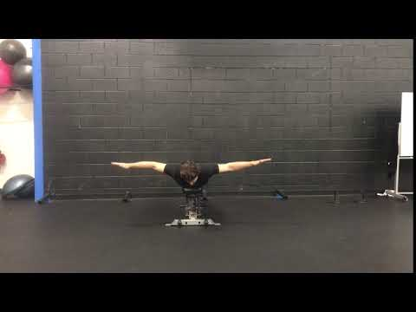](https://www.youtube.com/embed/S235lkmE8t0?feature=oembed)

**2A**: DB ROW

[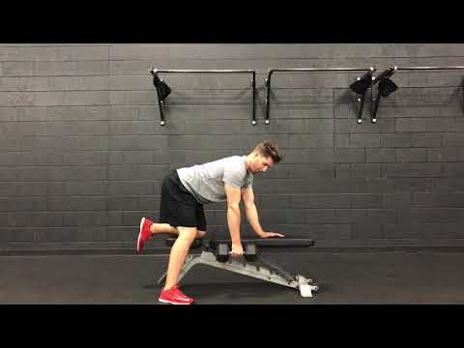](https://www.youtube.com/embed/9JbXfRk1ZBI?feature=oembed)

**3A**: LATERAL RAISES

[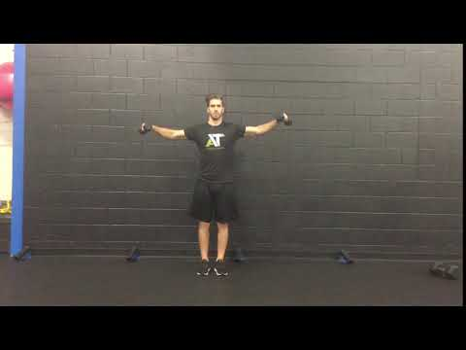](https://www.youtube.com/embed/Gk4MgsXjCP4?feature=oembed)

**4A**: SMALL WEIGHT SHOULDER SERIES

* Use 3 lbs up to a maximum of 5 lbs after months of lifting.
* Emphasize the negative rep – slow lowering of the weight to the starting position over a period of 3 seconds. Don’t just let gravity take over when you get to the top of your motion. Hand/weight goes no higher than shoulder.
* Thumbs up to sky.

**5A**: DB STEP-UP

[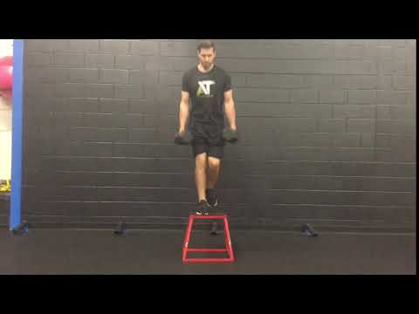](https://www.youtube.com/embed/EuIBUs-qHV4?feature=oembed)

**6A**: DB REVERSE LUNGE

[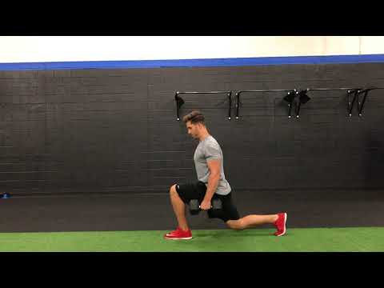](https://www.youtube.com/embed/cKZIKm5jfOw?feature=oembed)

**6B**: MEDICINE BALL ROTATION (Make sure to do sets from both sides regardless of which side you bat from).

[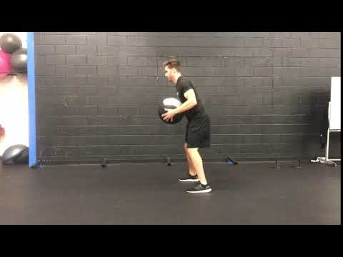](https://www.youtube.com/embed/WBs5PtchnHk?feature=oembed)

**CORE**: CABLE ANTI-ROTATION

[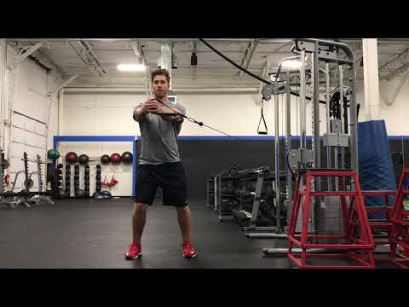](https://www.youtube.com/embed/yMb_UvCILjc?feature=oembed)

**CORE**: CABLE ROTATION

[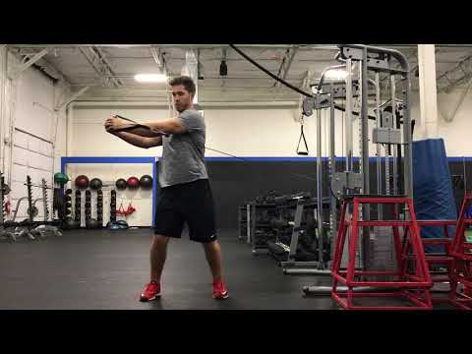](https://www.youtube.com/embed/gj6JCiUhTQ8?feature=oembed)

|  |  |  |  |  |  |  |  |  |  |  |
| --- | --- | --- | --- | --- | --- | --- | --- | --- | --- | --- |
|  | **Day 3** | | **Week 1** | | **Week 2** | | **Week 3** | | **Week 4** | |
|  | Weight | Reps | Weight | Reps | Weight | Reps | Weight | Reps |
| 1A | Pullups (Add band for assistance) | | 4 sets |  | 4 sets |  | 4 sets |  | 4 sets |  |
|  |  |  |  |  |  |  |  |
|  |  |  |  |  |  |  |  |
|  |  |  |  |  |  |  |  |
| 1B | Wall Slides | | 3x10 | | 3x10 | | 3x10 | | 3x10 | |
|  |
|  | | |  | | | | | | | |  |
| 2A | Single Arm DB Incline Bench | |  | 10 |  | 10 |  | 8 |  | 8 |  |
|  | 10 |  | 10 |  | 8 |  | 8 |  |
|  | 10 |  | 10 |  | 8 |  | 8 |  |
|  | 10 |  | 10 |  | 8 |  | 8 |  |
| 2B | Band Pull Apart | | 3x10 | | 3x10 | | 3x10 | | 3x10 | |  |
|  |
|  | | | | | | | | | | |  |
| 3A | High Cable Pulldown | |  | 10 |  | 10 |  | 8 |  | 8 |  |
|  | 10 |  | 10 |  | 8 |  | 8 |  |
|  | 10 |  | 10 |  | 8 |  | 8 |  |
| 3B | Scap Pushups | | 2x10 | | 2x10 | | 2x10 | | 2x10 | |  |
|  |
|  | | | | | | | | | | |  |
| 4A | Bicep Curls Tri- Pressdown Forearm Curls | |  | 2x10 |  | 2x10 |  | 2x10 |  | 2x10 |  |
|  | 2x10 |  | 2x10 |  | 2x10 |  | 2x10 |  |
|  | 2x10 |  | 2x10 |  | 2x10 |  | 2x10 |  |
|  |  |  |  |  |  |  |  |  |  |  |  |
| 5A | DB Split Squat | |  | 10 |  | 10 |  | 8 |  | 8 |  |
|  | 10 |  | 10 |  | 8 |  | 8 |  |
|  | 10 |  | 10 |  | 8 |  | 8 |  |
|  | 10 |  | 10 |  | 8 |  | 8 |  |
| 5B | Lateral Band Walk | | 2x10 | | 2x10 | | 2x10 | | 2x10 | |  |
|  |
|  |  |  |  |  |  |  |  |  |  |  |  |
| 6A | Swiss Ball Curl Up | |  | 10 |  | 10 |  | 12 |  | 12 |  |
|  | 10 |  | 10 |  | 12 |  | 12 |  |
|  | 10 |  | 10 |  | 12 |  | 12 |  |
|  | 10 |  | 10 |  | 12 |  | 12 |  |
| 6B | Glute Bridge | | 3x30 seconds | | 3x30 seconds | | 3x30 seconds | | 3x30 seconds | |  |
|  |

**CORE:**

Swiss Ball Holds: 2 set x 30 second hold

Swiss Ball Rollout: 2 set x 10 reps

VIDEOS AND/OR INSTRUCTIONS FOR DAY 3 LIFTS

**1B**: WALL SLIDES

[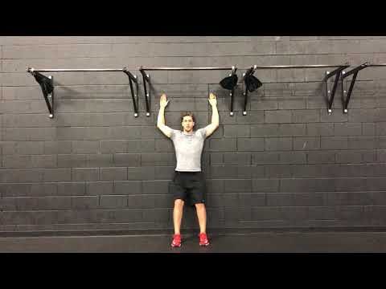](https://www.youtube.com/embed/D-YyO8-ZWsY?feature=oembed)

**2A**: SINGLE ARM DB INCLINE BENCH PRESS

[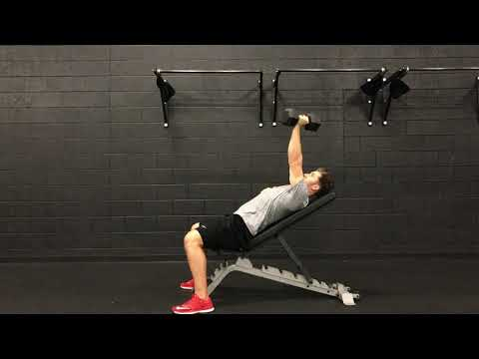](https://www.youtube.com/embed/rVhc7474QxA?feature=oembed)

**2B**: BAND PULL APART -SEE PREVIOUS VIDEO FROM DAY 1 (SAME)

**3A**: HIGH CABLE PULL DOWN

[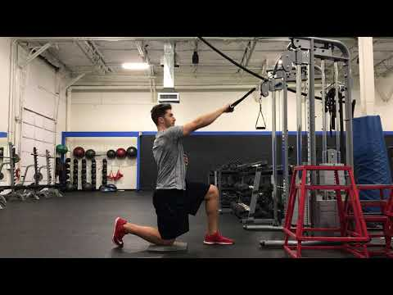](https://www.youtube.com/embed/5urzCZvDGrk?feature=oembed)

**3B**: SCAP PUSHUPS

[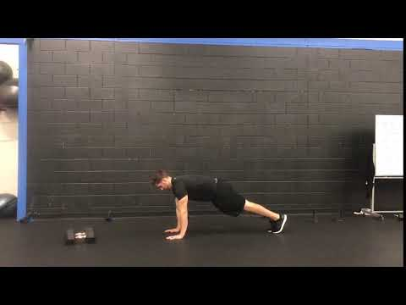](https://www.youtube.com/embed/Rf3T9gzTjHY?feature=oembed)

**5A**: DB SPLIT SQUAT

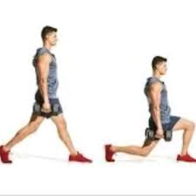

**5B**: LATERAL BAND WALK

[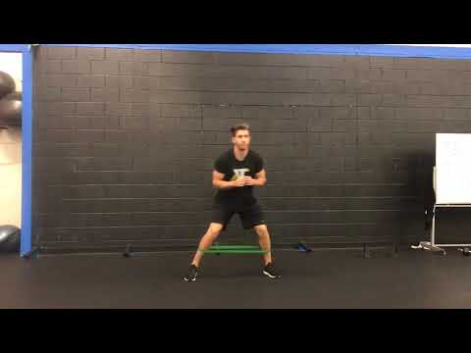](https://www.youtube.com/embed/oLcio9enxdQ?feature=oembed)

**6A**: SWISS BALL CURL UP

[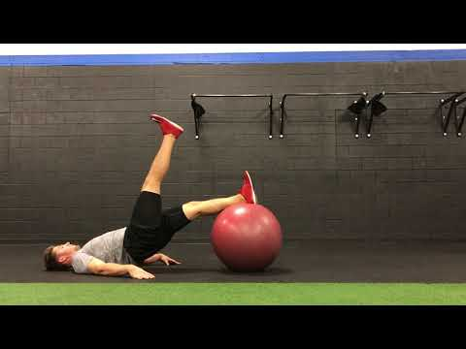](https://www.youtube.com/embed/VVD21WDWLzc?feature=oembed)

**6B**: GLUTE BRIDGE

[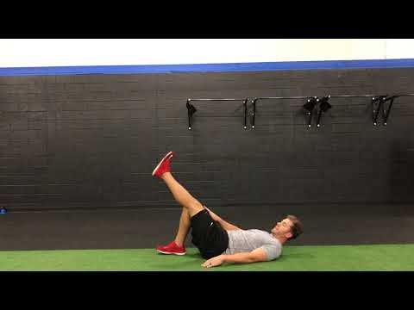](https://www.youtube.com/embed/X78cZykCQZo?feature=oembed)

**CORE**: SWISS BALL HOLDS

[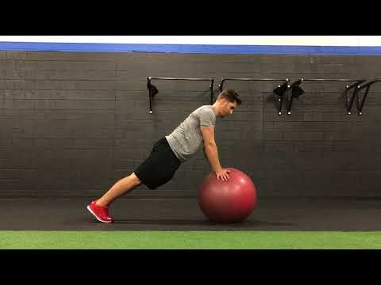](https://www.youtube.com/embed/Vp0tVymL7jE?feature=oembed)

**CORE**: SWISS BALL ROLLOUT

[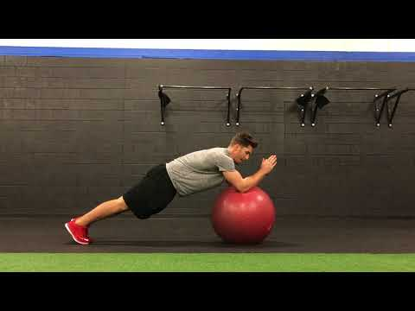](https://www.youtube.com/embed/L_FSTbwWv3E?feature=oembed)

VIDEOS AND/OR INSTRUCTIONS WARM-UPS

**WARMUP**: INCHWORM

[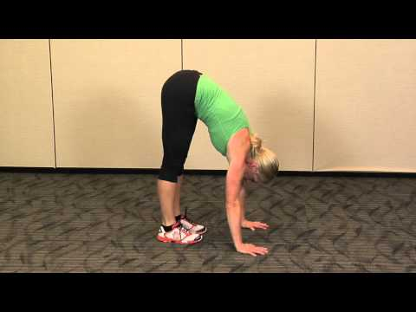](https://www.youtube.com/embed/Z19gpqxQBwo?feature=oembed)

**WARMUP**: REVERSE LUNGE TO HIGH KNEE

**[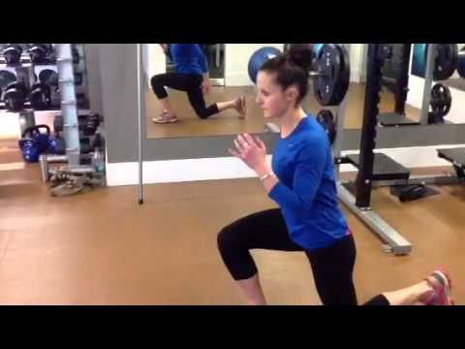](https://www.youtube.com/embed/67czSesufKc?feature=oembed)**

**WARMUP**: LIGHT SKIPS

[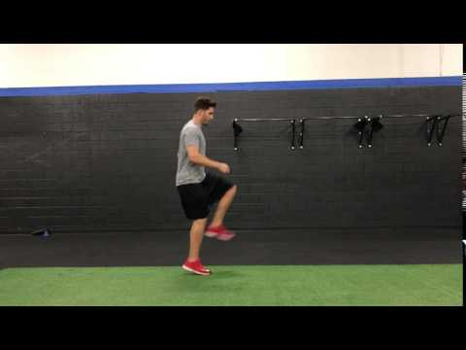](https://www.youtube.com/embed/WeP8qjegIp4?feature=oembed)

**WARMUP**: LATERAL SKIPS

[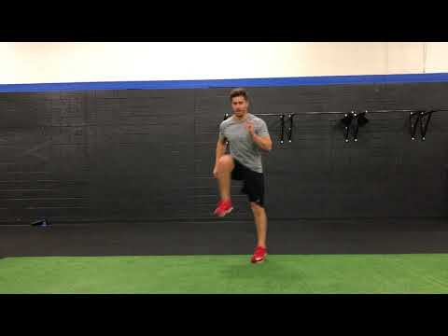](https://www.youtube.com/embed/G76D6EUt-3E?feature=oembed)