What your locker SHOULD NOT look like... What your locker SHOULD look like!!!!!

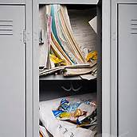 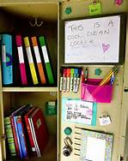

What your binder SHOULD NOT look like…. What your binder SHOULD look like!!!!!

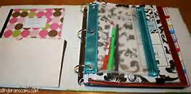

What your back pack SHOULD NOT look like…. What your back pack SHOULD look like!!!!!

