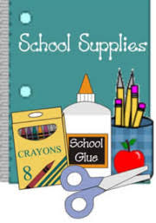

Please make sure your child brings a traditional sized backpack to school each day. Also your child will need supplies at home for practice work, writing, coloring, cutting, gluing.

We provide classroom supplies but often run out before the end of the year. If you visit the back-to-school sales, we appreciate donations. Please donate if you can.

1. Elmer’s Liquid Glue
2. Elmer’s Glue Sticks
3. Crayola Twistable Crayons
4. Colored Pencils
5. Skinny Markers
6. Fat Markers
7. No. 2 Pencils
8. Scotch Tape



1. Box of Tissues

2. Inexpensive cleaning wipes (used for hand cleaning)

3. Sanitizing Wipes (for cleaning surfaces)

4. Paper Towels

5. cups, plates, bowls, napkins, plastic ware

6. gallon zip bags (boys) quart zip bags (girls)



1. White Cardstock
2. Colored Cardstock
3. Laminating Pockets (9x12 3 mil.)
4. Painting Paper (9x18)
5. Craft Supplies (craft sticks, beads, pipe cleaners, yarn, pom poms, googly eyes)
6. Expo Markers